http://www.electricscooterparts.com/escooter24v250welectricscooterparts.html
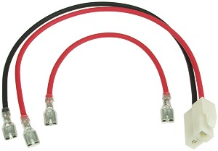

Battery Wiring Harness for E-Scooter 24 Volt 250 Watt Electric Scooter
Battery pack wiring harness for the E-Scooter 24 Volt 250 Watt electric scooter. The original wiring harness may be soldered onto the batteries and practically impossible to remove. Make battery pack replacement an easy job with a brand new wiring harness.
Item # HNS-100
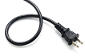 | 1-800-908-8082 8am-5pm Pacific Time Monday-Friday

ElectricScooterParts.com Support Center
Welcome
Login Sign up
HomeSolutionsForums

Activate your account

ekims1@aol.com

Full Name
Create a Password
w
Retype Password
w
Activate & Log in

Copyright© 2016 by ElectricScooterParts.com, an Electricruz Inc. company. All rights reserved.

